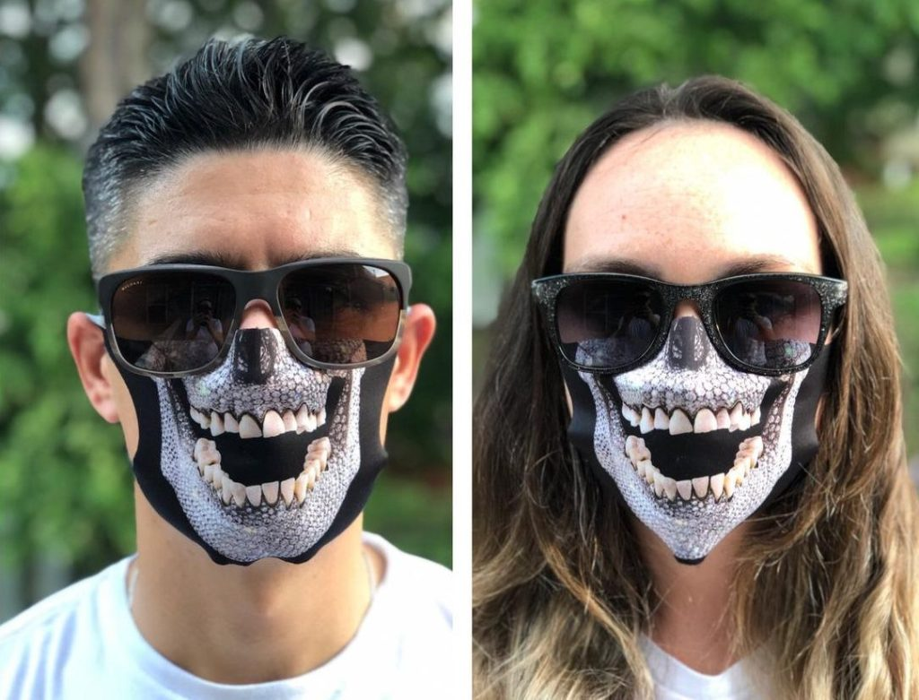

COVID INCORRECT

You are generally a good person but it didn’t take long to see you couldn’t pass the test. The test of political sacrifice, the challenge of handling responsibility, the rising above the lines that were drawn by a disaster of epic …. or pandemic.... proportions. As a politician you were naive, as a citizen you were greedy. When Covid engulfed the planet, there were those that felt that it was a conspiracy, and there were those who went to the extremes who envisioned the end of human life as we know it. No one knew how to handle it, least of which was you. You sat on the fence, misrepresented facts, attacked your neighbors for not wearing masks, or caused firefights on Facebook by your mere criticism of those that that did not follow your God appointed rules. At times, you ran a pharmaceutical company that mixed up the facts; at times you were a politician that thought bleach was the best way to rid oneself of the virus. You ran campaigns while cavorting mask less in ritzy restaurants while proclaiming that there was no pandemic. You were reminded of the canard of the famous children’s nursery rhyme “Ring around the Rosie.” A pocket full of posies? Not so much. More like plague infected buboes from which everyone kept their distance the last time a plague infested the corners of the world. Ashes! Ashes! We all fall down!

But the wagons have gone full circle, and there are you are, caught in the middle with your pants down while a pandemic is raging. Your ratings are down, way down, and you have to salvage some element of human respectability. You have endangered the lives of innocents, and by your polemic compromised the safety of your neighbors. You’ve forced social distancing down their throats, but then changed your mind and opposed mass vaccinations. Why are you such an idiot? The road to progress may be long and winding, but it is paved with potholes. And you’re in one of them. How do you save yourself? How do you make amends? Is it a virus, or is it a manufactured tale? Want to make a Zoom call? I hear there’s no one at the front desk.

1. COVID, COVID, a creepy virus so very novel,

Around a President’s feet you are forced to grovel,

What better Caesar to deify?

The Donald Trump we can’t deny,

For all his efforts on this pandemic,

The answer should be academic!

What’s the best way to kill the virus?

Act and sing like Billy Ray Cyrus?

Or better than that, find the right injection,

Of an intravenous confection,

Is the solution right here under your nose,

As close to you as your skin to your clothes?

Often used to clean laundry whiter,

The second floor might make things brighter,

You won’t need to drive to obtain the solution,

But you might sense an impending revolution,

It wasn’t the media that wove a spin,

A political cycle to now begin,

You were up to your socks in hot water,

But now your situation is even hotter.

1. Cuomo got himself in a bind,

When he filled all the nursing homes, so unkind!

Leaving the elders in congested places,

The figures showed unhappy faces,

His numbers of Covid deaths increased,

While his political capital decreased,

Just off South Congress is your fire,

Near a place called Stonebriar,

Show your ***essential magnificence,***

By photographing your team near this residence.

The place for this daring photo shoot,

Is across from where you find the loot,

Finally in order for you to commence

Complete the below so your little clue makes sense.

|  |  |  |  |  |  |  |  |  |  |  |  |  |  |  |
| --- | --- | --- | --- | --- | --- | --- | --- | --- | --- | --- | --- | --- | --- | --- |
|  |  |  | 1 |  |  |  |  |  |  |  |  |  |  |  |
|  | 2 |  |  |  | 3 |  |  | 4 |  |  |  |  |  |  |
|  |  |  |  |  |  |  |  |  |  |  |  |  |  |  |
|  |  |  |  |  | 5 | 6 |  |  |  |  |  |  |  |  |
|  | 7 |  |  |  |  |  |  |  |  |  |  |  |  |  |
|  |  |  |  |  |  |  |  |  |  |  |  |  |  |  |
|  | 8 |  | 9 |  |  |  | 10 |  |  |  |  |  |  |  |
|  |  |  |  |  |  |  |  |  |  |  |  |  |  |  |
|  |  |  | 11 |  |  |  |  |  |  |  |  |  |  |  |
|  |  |  |  |  |  |  |  |  |  |  |  |  |  |  |
|  |  |  |  | 12 |  |  |  |  |  |  |  |  |  |  |
|  | 13 |  |  |  |  |  |  |  |  |  |  |  |  |  |
|  |  |  |  |  |  |  |  |  |  |  |  |  |  |  |
|  |  |  |  |  |  |  |  |  |  |  |  |  |  |  |
| Across | |  |  |  |  |  |  | Down |  |  |  |  |  |  |
| 2. Take the __ and get the vaccine! | | | | | |  |  | 1. Covid can attack your __ and give pneumonia | | | | | | |
| 5. Covid is a _____ | | | |  |  |  |  | 3. Cuomo was the ___ of NY | | | | |  |  |
| 7. You should ___ to #4 | | | |  |  |  |  | 4. Immunologist Dr. ____ is Director of the | | | | | | |
| 8. DeSantis wants Floridians to wear _____, | | | | | | |  | Nat'l Institute of Allergy and Infectious Diseases | | | | | | |
| and not masks | | | | |  |  |  | 6. ___ & out | |  |  |  |  |  |
| 11. Certain hallucinogens, informally (fungi) | | | | | | |  | 7. Trump thinks you can sue for ____ just for | | | | | | |
| 12. Solution to Clue 1 - what Trump thought | | | | | | |  | printing the truth | | | |  |  |  |
| was the answer to our Covid woes | | | | | |  |  | 9. Only air ___, not on the lips! | | | | |  |  |
| 13. Toy on a string | | | |  |  |  |  | 10. Sick to one's __ = nauseated | | | | |  |  |
|  |  |  |  |  |  |  |  | 12. Too young to be a man | | | | |  |  |

1. Onward Ho! Or should I say whore?

As California’s head of state, it’s quite a chore

To pretend that Covid is so rampant,

You’re the media’s great sycophant,

But being caught with your pants down,

While partying at a restaurant like a clown,

You yell to the populace “You best beware!”

But you had no masking there,

Your name is Newsome, I presume,

Was it some French legume?

That made your ratings completely fall,

Resulting in your quick recall?

Your popularity’s being taken to the cleaners

By voters angry with your misdemeanors

If you want to stay in the capitol,

Try not to be so hypocritical,

At S . First near a thunder cat you’ll find,

A rousing way to restart your climb.

1. Start your mission to find some penance,

So that your conduct will find remembrance,

The *b*est thing would be to he*a*d west,

Whe*r*e it’s *t*ime to meet your test.

Off Lou Neff R*o*ad is an outcr*o*pping,

Upon its crest you should be stopping,

From rocky searches good luck springs,

Parking wo*n*’t be an easy thing.

Indeed, you’ll view downtown from a distance,

In this park with verdant waterfronts.

1. Under the shadow of a hotel,

Is the place to break this spell,

Was it a lab leak after all?

That caused your disastrous fall?

It’s now time to toe the LINE,

Where the Bat Woman left a sign,

Where Covid spread its pandemic,

The question is so academic,

The stairs are off a legislative street

Stay outside, go down, and you’ll soon be complete,

Don’t go boating; that’s not why you’re here,

You’re looking for the cause of this shitty year,

You’ll surely get your viral fill,

When you see founders Jonna and Jill.

1. It seems the world would be so full of ***joy***,

At a place that sells some excellent ***toy***s,

The pandemic seemed so unfair,

By making neighbors “stay over there,”

Where are the parties and Second chances?

No smiles, no hugs, only sideways glances,

It’s now time to find one last mask,

That will now keep you up to task,

Andrew and his staff are cool with you there,

But you don’t have to sing in order to snare,

You might want to announce just who you are,

Or you and your clue won’t get very far.

1. Near a Power Plant they say, “Go West, young man!”

A blue organism awaits your command,

You’ve learned all you can from public books,

You shouldn’t get many dirty looks,

On a street corner so unexpected,

You’ll get what you need to be uninfected,

Rally César thinks you’ll find outdoors,

Something that might kill those spoors,

There you might find the cleaner you need,

That just might eradicate the dying breed,

Of the virus that took so many lives,

There’s no room left for compromise.

1. You know how going *upstairs* is a bitch,

From those moments when you felt that Covid itch,

It’s not hard to generalize,

When you’ve been such a pussy otherwise,

It’s been such a circus with restrictions galore

(And all those precautions you did deplore),

It’s all DIY but with a bar,

Luckily for you not very far,

1 2 3 4, and sideways you go,

And lose the 1 a ***Second*** ago,

Don’t lose yourself going pell-mell,

You must check in under Marc Chomel.

1. Time to bar hop to 208 W. *Fourth*,

*And* in good *company* sally north,

Don’t go to the bar below,

Unless you are among the Down Low,

Senior Austinites who are in the know,

Will recognize the neighborhood from old Fado’s,

To the bartender sing your rhyme,

And his retort might be sublime,

It may well indicate where to search,

So you’re not completely left in the lurch,

Versinthe shots are now required,

If for Covid protection you’ve aspired,

There may be singers and drag show sass,

Listen to your bartender; don’t be crass,

Announce yourselves as Covid Incorrect,

And treat the bartender with respect,

He will have your indication,

Of the perfect club location*.*

1. It’s time to put your ***foot*** down somehow,

Across from an Italian Tavern you now plow,

Many singers recovered from Covid’s threats,

Getting **Moody** would help your bets,

This singer often shared his joints,

For this he gets no Covid points,

The only thing about him that is not 420,

Is his address you Covid cognoscente,

So go ahead and have a Covid “cow,”

You’ll recognize him in bronze anyhow.

1. You’ve survived Covid and political fallout,

Frankly you’re cranky and worn out,

You’ve earned a rest and a libation,

You’re closer than you think to your destination,

One last clue in your hand to make you think,

Then you’ll have earned your pandemic drink,

The statue gives you the final clue,

And when it’s read you’ll know what to do.

LITTLE CLUES

1. In dryer with socks and underwear

The New York Governor was disenchanted,

By rumors the media cleverly implanted,

They said he stuffed the eldest past their prime,

In homes where the pandemic had its time,

More died under his inept supervision,

Because of his rampant indecision,

Across from a 🞏🞏🞏🞏 🞏🞏🞏 at 110,

It’s time for Cuomo to start again,

Under the Star of the Lone Star State,

Where a lizard and armadillo congregate,

This pergola lets you social distance,

And provides Covid clue assistance.

1. In place across from Stone Briar

To launder politics is quite a bitch,

If you don’t have that certain itch,

To Capitol Cleaners you must go in,

And find the mask you left without chagrin,

To complete your last conceit,

Your very bag holds the receipt.

3. In mask at laundry

Head to a park that by any other name,

Would have Zilker in its game,

Near five volleyball nets and sand,

You’ll see where you need to make your stand

A rocky mound just at the top,

Is the place for your next drop.

If you’re not to become completely unhinged,

Find the place where hides the syringe,

Nearer to downtown you’ll perceive

That solution you want to receive

1. In syringe

You will make some excellent progress

If you visit this downtown part of Congress,

The bridge to knowledge helps your head

You’ll soon see how the virus spread

Down some steps to tree-lined path

Don’t trip and fall or you’ll take a bath

On the circled viewpoint you’ll soon see,

How the virus was allowed to go free.

1. At bat view point – leads to Toy Joy

On West Second is a sure-**f**ire bet,

To disc**o**ver now yo**u**r last reg**r**et,

If y**o**u **h**ad masked bet**t**er long ago,

Your career would not be suc**h** a lurid peep show.

If your vax ca**r**d helps you regist**e**r,

Near the front desk no infections f**e**ster.

1. In mask at toy store

The world thinks it best to sanitize,

Your hands and face and all those lies,

Near the central public library is where you should go

To put an end to this shit show,

You better find that bottle now,

To spray upon your hands somehow,

A cerulean bulbous being awaits nearby,

Behind his mutant body the clue espy.

1. In/On sanitizer bottle

You’ll need to make some arts and crafts,

Lest the public think you’re daft,

Only an idiot could give so much sass,

Show them that you’re some ***bad ass,***

A ***leather cuff*** will do the trick,

Your circus days are in the thick,

Make sure to get there from three to six,

Or you’re sure to be in a rotten fix.

1. At Upstairs Circus behind vaccination card

Though you’ve travelled for so long,

It’s now time to sing a song,

It’s about that nasty plague in London times,

With its stupid nursery rhymes.

On your vaccination card you’ll surely find,

A place where you can now unwind,

Drink and chat but please don’t lag!

The rhyme you chant is in your bag.

1. At fourth street bar under or behind couch that says “This too shall pass.” Bartender gives this clue and throws petals at them.

Getting your vaccine is willie cool,

At ACL, don’t be a fool,

Too many country singers have lost their stride,

Duffie, Prine and Charley Pride.

On a corner sits one who’s still with us

Go see him now for a weed lover’s Christmas

1. At Willie Nelson statue/under social distance signs

10.

In the alphabet, there’s a letter,

It’s the 23rd, it doesn’t get better,

That’s your destination to which to fly,

(Which will also have drinks to fortify)

200 Mexican Cows will get you there,

Check in now, or lose your fare.

RING AROUND THE ROSIES

Ring-a-ring-a-rosies  
A pocket full of posies  
A tissue, a tissue  
We all fall down

The king has sent his daughter  
To fetch a pail of water  
A tissue, a tissue  
We all fall down

The robin on the steeple  
Is singing to the people  
A tissue, a tissue  
We all fall down

The wedding bells are ringing  
The boys and girls are singing  
A tissue, a tissue  
We all fall down

COVID 19 Vaccination Record Card **CDC**

Last name: COVID ANTI-VAXXERS

Date of Birth: Old and vulnerable

**Vaccine**

**Pfizer**

1st Dose 3/13/21 **4th Street Bar**

2nd Dose 4/21/21 **THE COW**

Though you’ve travelled for so long,

It’s now time to sing a song,

It’s about that nasty plague in London times,

With its stupid nursery rhymes.

On your vaccination card you’ll surely find,

A place where you can now unwind,

Drink and chat but please don’t lag!

The rhyme you chant is in your bag.